Milestone 3

Kate Pendavinji ([kape6379@colorado.edu](mailto:kape6379@colorado.edu))

John Ortiz ([joor0056@colorado.edu](mailto:joor0056@colorado.edu))

Figma Prototype: <https://www.figma.com/proto/IV1t3Etw8E4PrlBeB0Xcwi/Prototype?node-id=2%3A4&scaling=scale-down>

Figma Link: <https://www.figma.com/file/IV1t3Etw8E4PrlBeB0Xcwi/Prototype?node-id=0%3A1>

Feedback from **Will**:

* First Task: *Add Bob to regimen*
  + After one full runthrough of the prototype without selecting the contacts button, Will finally clicked the contacts button, tried to add himself, and finally added Bob to regimen 2.
  + There were a lot of obstacles initially. Will didn’t even click the contacts button at all through his first runthrough. I had to prompt him to try out every button to see what it did the second time around and then it ran seamlessly.
  + Seemingly our users like to click the regimen page first, so in this case we must change/remove our home page and create accessibility to our contacts from our regimen page.
* Second Task: *Add a regimen*
  + Will also avoided the add regimen button the first go around, but the second time he tried to add a regimen multiple times. He then realized we have a fixed regimen that can be added.
  + This had similar obstacles to the first task-- it wasn’t intuitive that adding a regimen was required, so after prompting him to try out all the buttons he figured it out. He also was unhappy with the fact that he could only add one regimen.
  + This could be fixed with more test cases being added so if we created more regimens to be added to the regimen page and updated at a larger scale. I also didn’t see this as too great of an issue because although adding a regimen is one of our tasks, the app is still functional with the set amount regimens included.
* Third Task: *Add exercise to regimen in call*
  + Will immediately went to the regimen page and started a workout. He decided he did not want to add box jumps, but box jumps were added anyways. He then tried to end the call by pressing the red end call button instead of pressing “go home”.
  + This was more seamless than the rest, he pretty much got it on the first try. The only obstacle we ran into was that he didn’t want to add box jumps, and decided to add them the second time around. He also didn’t like that the buttons in the image weren’t functional.
  + This could be improved by having another test case that if a person does not want to add a workout then it will not automatically add it like we have it. Also we can make those buttons functional and go to the home/login page.
* Other Notes:
  + Only way to choose high intensity or low intensity is if we go through contacts
  + Would like more options of workouts
  + You have to have some way of communicating that you are going to facetime someone
  + He thinks you should only be able to add an exercise after your workout is done
  + Scheduling-- weekly workouts, app notifies you if your weekly workout is starting
  + Looks very bad, but buttons are distinguishable--maybe add borders & pictures
  + Have a logo or something to make it seem like an app
  + Tutorials for workouts

Feedback from **Julia**:

* First Task: *Add Bob to regimen*
  + Julia first did not click the Contacts button and clicked the regimen button instead. Which was a big halt on adding a contact. After realizing that she needed to go back she did and did have any other problem adiding bob.
  + She was confused because the regimen page can also add people if you are creating a new regimen.
  + A way we could solve this is to constrain the regimen add page to not add people; leaving that functionality to the Contacts pages.
* Second Task: *Add a regimen*
  + The initial regimen page was fine when she clicked it; however, when Julia got to the AddNewRegimen Page she got stuck, trying to enter the data.
  + Julia did not like design of a new regimen page was stuck trying to get through it
  + I believe there are multiple options on how to change the prototype. The first option would be to ask if all the fields of data on the Page should be required? If so, good or bad constraint? The other option would be to add feedback that if they click the confirm button before they finish filling the info in, a notification or feedback is produced that they need to finish filling in the information.
* Third Task: *Add exercise to regimen in call*
  + Julia clicked the workout page as intended,started the “video call” ,added the exercise, and then got stuck trying to find the next button. After a bit of looking she found the next workout and proceeded to finish the video, with successfully adding box jumps.
  + Expressed a lot of confusion of the organization of the video call screen. Julia thought that it should be made more clear that there is a queue of exercises, not just one exercise.
  + A way we could fix the user not understanding what is presented by giving more flamboyant feedback each exercise to show it is a queue without stating it.
* Other Notes
  + Did not like different text box sizes for the user input, she thinks that each box should be the same
  + Does not like the boring aesthetics of the project
    - Does not like to see too much gray, white, or black
    - Not interesting design layout
    - Very minimalistic
  + (**Task 3)** Julia believes that there should be more constraints on what type of exercise one could add to the queue; that means that users would not be able to input their own text but able to select from a list of options.

Improvements Made:

* The biggest issue we decided was our users' confusion on how to add a contact. Each user clicked the wrong button leading them to the wrong task. We decided if we constrain the contacts button to the registration page we can guide the users to better complete and understand their assigned tasks.
* Before: Home page still present, no way of accessing contacts from regimen page

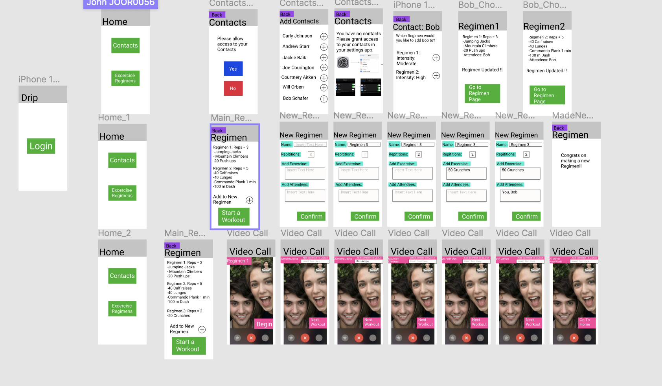

* After: Login takes you straight to regimens & contact accessibility is now available on the regimen page

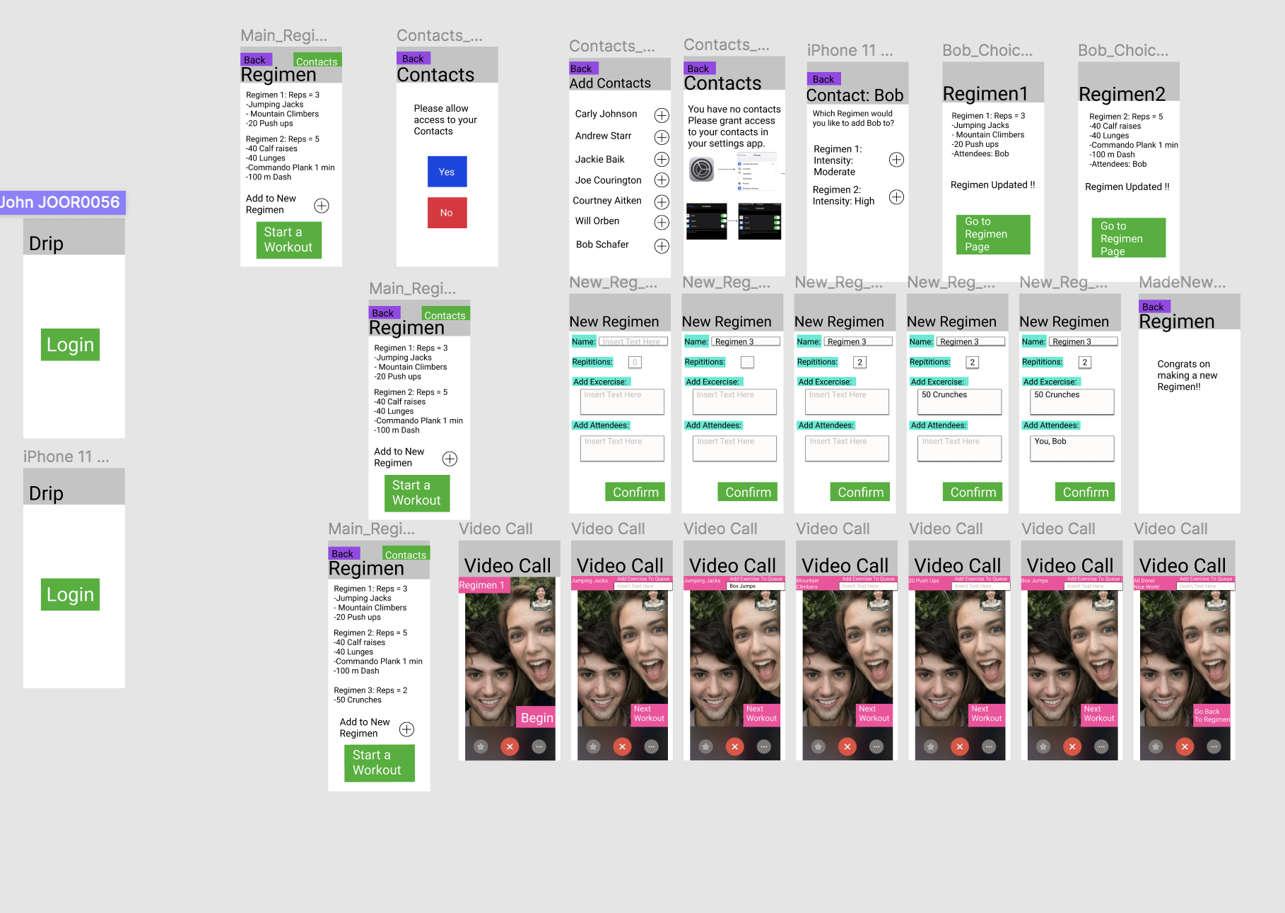

**Below is the message we distributed to my user test case for documentation:**

Hello, welcome -**NAME**-

This project is an application that connects friends to workout in sync, make group workouts sessions from a distance. It can be used to help promote better mental health by allowing the social interaction every 18-22 year is wanting due to covid…

As a participant you should verbalize your thought process:

- Layout

- Buttons , what you think they do

- Graphics

- “Thinking out loud” technique

Please Complete the tasks in order:

**First Task:**

Imagine you have one of your child's best friends that really wants to workout with you. So, you download our app **DRIP.** You now face the task of adding your friend Bob Schafer to a workout regimen through your contacts.

**Second Task:**

Now you deal with another dilemma, you want to add exercises to a Regimen. So, your task will be to create a new regimen with one exercise.

**Third Task:**

Inside the application you want to start a workout with your friend. But you think you want to do a little extra work today. So, your task is to start a video call and add “box jumps: to the regimen on a call.

If you have any questions please refrain from asking… Instead voice your concern and feedback